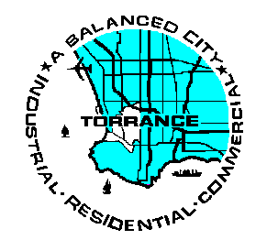 | City of Torrance Fore Department  Fire Prevention Division  3031 Torrance Blvd. Torrance, CA 90503  Phone: 310.618.2973 Fax: 310.7817506  National Pollution Discharge Elimination System (NPDES)  Storm Water Inspection Report Industry Dry Cleaners
Business Name: |  |  | Date:
Business Address: |  |  | Phone:
Type of Facility: |  |  | SIC Code: 7216
Key: Y-BMP Implemented; N-BMP Not Implemented; NI-Needs Improvement; N/A-Not Applicable
Best Management Practices (BMP’s) | BMP Effectiveness |  |  |  |  | BMP Effectiveness
Best Management Practices (BMP’s) | Y | N | NI | N/A |  | Y | N | NI | N/A
Dry Cleaning Machine has no leaks. (If leaks are present, no liquid runs outside on the property and/or to a storm drain.) |  |  |  |  | Dumpster area is clean and lids closed
Washing machine drains to a sanitary sewer system. |  |  |  |  | Outside areas are swept and trash is placed in the garbage.
Facility properly manages raw waste materials including proper disposal of hazardous materials: |  |  |  |  | Parking areas are kept clean.
Storage of filters: container covered if stored outside |  |  |  |  | Employees:
Storage of waste perc: stored in a container with secondary containment |  |  |  |  | Know the restriction on discharging non-storm water to the storm drains.
Storage of soap or water conditioner: if outside needs secondary containment and a cover on the container. |  |  |  |  | Know to keep dumpster area clean and lids closed.
All water is drained to a sanitary sewer system. |  |  |  |  | Know not to place wash water or any other liquid into dumpsters.
Building and Ground Maintenance |  |  |  |  | Know how to respond to hazardous spills before it enters the storm drain.
All storm drains located on the facility’s property are labeled, inspected, and routinely cleaned. |  |  |  |  | Knows not to hose down shop floor or other locations that could impact storm drains.
Additional Violations/Comments:
This report is an assessment of this facility’s implementation of the BMP’s. This facility is required by federal law to follow all required BMP’s. Any violations will be corrected within 30 days of receiving this report. A follow-up inspection may occur to verify these corrections. Failure to comply will result in an enforcement action.

Inspector: | Inspector’s Signature:
Facility Representative: | Facility Representative’s Signature:

