Torrance Fire Department
Fire Prevention Division
3031 Torrance Blvd.
Torrance, CA 90505
(310) 618-2973
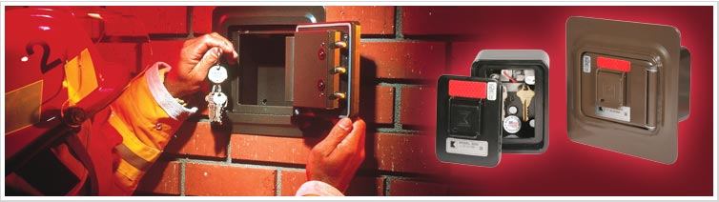
The Knox-Box® Rapid Entry System is a secure emergency access program developed for property owners and first responders. First Responders across North America use the Knox-Box Rapid Entry System to prevent costly entry damage while protecting property and lives. When a fire breaks out or there is a medical emergency, Knox® products allow immediate entry into buildings and property without forced entry damage or delay. Property owners store entrance keys, access cards and floor plans in high-security Knox-Box key boxes mounted near building entrances. Each Knox-Box purchased by a property owner is keyed to a single master key controlled by the local responding department.


Torrance Fire Department
Fire Prevention Division
3031 Torrance Blvd.
Torrance, CA 90505
(310) 618-2973
The Knox-Box® Rapid Entry System is a secure emergency access program developed for property owners and first responders. First Responders across North America use the Knox-Box Rapid Entry System to prevent costly entry damage while protecting property and lives. When a fire breaks out or there is a medical emergency, Knox® products allow immediate entry into buildings and property without forced entry damage or delay. Property owners store entrance keys, access cards and floor plans in high-security Knox-Box key boxes mounted near building entrances. Each Knox-Box purchased by a property owner is keyed to a single master key controlled by the local responding department.


