**Welcome to the Spanish/English Book Club**

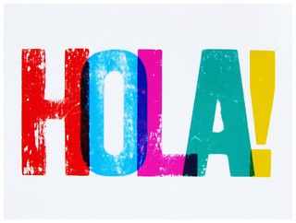

**First meeting will be held on Tuesday, July 25, 2023 at 10:00 a.m.**

**And after the first meeting we will be meeting regularly the second Tuesday of every month at 10:00 a.m. All meetings will be held at the Bartlett Senior Center 1318 Cravens Avenue.**

**Victoria Spiegel will be the group moderator**

** For more information, please call the Bartlett Senior Center at (310) 320-5918**