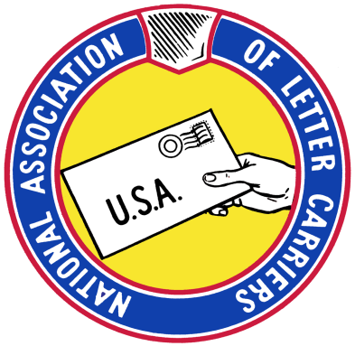**Saturday**

**May 14, 2022**

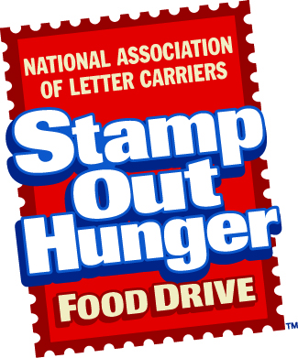**NALC 30th Annual**

**Every 2nd Saturday in May!**

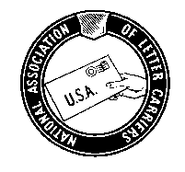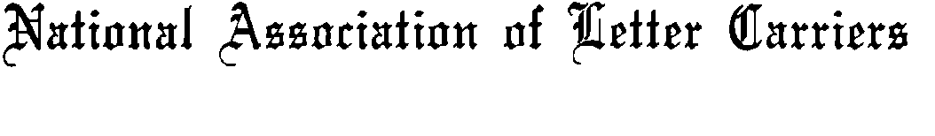

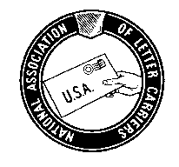

**SUNSHINE BRANCH 2207**

**P.O. BOX 3434**

**TORRANCE, CALIFORNIA 90510**

**310-782-2207**

**SATURDAY, MAY 14, 2022**

**NALC LETTER CARRIER’S 30th**

**ANNUAL FOOD DRIVE!**

**Items needed but not limited to:**

**Non-Perishable Canned Goods or Dry Food:**

* Canned Meats, Fish, Soup, Fruits, Vegetables
* Pasta
* Hot & Cold Cereal
* Macaroni & Cheese
* Rice
* Beans
* Peanut Butter
* Water

**Personal Care Items:**

* Diapers
* Toothpaste And Toothbrushes
* Toilet Tissue
* Body Soap
* Body Oil

**\*\* Please No Expired Items Or Glass Containers. \*\***

**SATURDAY, MAY 14, 2022**

**You may leave your bag(s) of food at your mailbox, or drop off bag(s) of food at your local post office, and/or give your donation to any letter carrier!**

**Thank you so very much!**

**The National Association Letters Carriers**

**Appreciates you and your support!**