[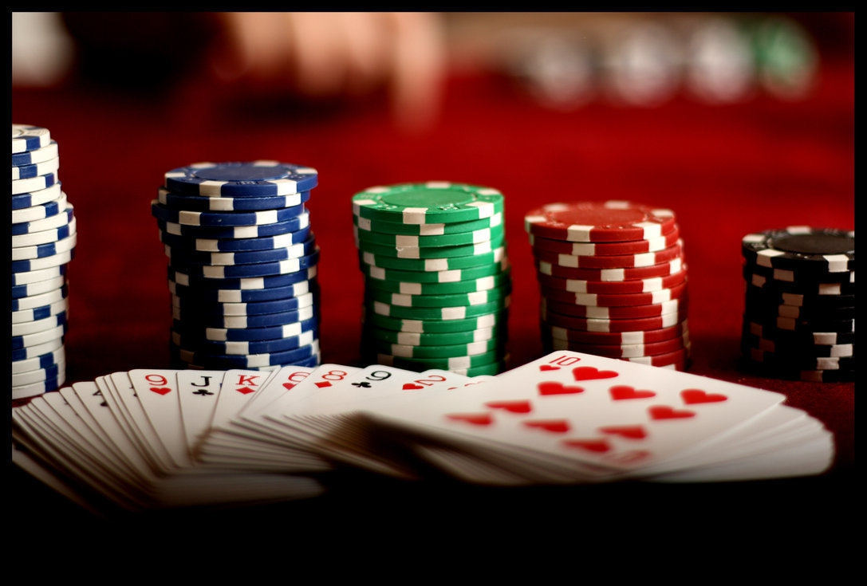](http://www.google.com/url?sa=i&rct=j&q=&esrc=s&frm=1&source=images&cd=&cad=rja&uact=8&ved=0ahUKEwiIqvnXo9vPAhXCOiYKHQEEAbkQjRwIBw&url=http://www.capitalpride.org/events/team-dc-winter-casino-night/&psig=AFQjCNH2UmR5ubDM8f41NkvJbeLot-LGWg&ust=1476567776019889)

Casino Night

**Bishop Montgomery High School Fundraiser**

Double up your winnings, and upsize your fun.

**You’ll enjoy great music, heavy hors d oeuvres, a hosted bar and fun prizes. If you don’t gamble, come to eat, drink and dance to a live band**

**Don’t miss your chance to hit the jackpot.**

**Saturday, November 9th, 2019**

**Brookdale South Bay (Across From BMHS)**

**5:00 to 9:00 p.m.**

**$30.00 Entry Fee pre-sale $35.00 at the door**

**Beer, Wine, and Hosted bar. Free Valet Parking**

**RSVP Today Mr. Marafino: amarafino@bmhs-la.org 310.540.2021x246 Amy 310.540.2021 x 249**

**Jeanne Hagmaier** [**Jhagmaier@brookdale.com**](mailto:Jhagmaier@brookdale.com)